Information and
Application Pack

Dear enquirer,

Thank you for your interest in hospital radio, in particular for your interest in the Edinburgh Hospital Broadcasting Service, known as red dot radio.

Please read through the information in this pack carefully; the information pages will give you a good idea of what we are about. If, after reading them, you would like to apply to join us then simply complete the application form in the pack and return it to me at the address given or by email attachment. Once the application form is received I will be in touch to arrange a date for you to come and spend the evening with us. Please be aware that at the current time it may take considerably longer than normal to arrange a visit due to covid restrictions.

If all goes well, we can then look to inviting you to become an Associate member (In Training) and you can begin your training period with us. If you have not heard from me within 2 weeks of posting your form please contact me by email so that I can check that it has in fact reached our studio through the NHS internal mail system.

I look forward to hearing from you.

Yours sincerely,

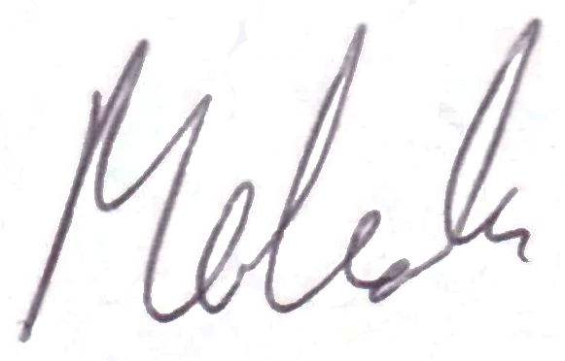

Malcolm Kirby
Chairman
enquiry@ehbs.co.uk

Information about EHBS

• Hospital Broadcasting in the UK

All over the UK, patients can hear music, news and information from their local hospital radio service. There are even a handful of hospital television services.

Hospital radio aims to provide comfort and entertainment to patients in hospital with a special mix of music and chat. The service also keeps patients in touch with their family and friends with music requests and local news items.

The Edinburgh Hospital Broadcasting Service (EHBS), popularly known as red dot radio because of the stickers on the bedside selection buttons, is one of three hospital radio stations in the Edinburgh area.

Like all hospital stations, EHBS is run entirely by volunteers. We have no paid staff and get no
regular income from the NHS or other Government sources.

The biggest reward for a hospital broadcasting volunteer is a letter from a patient who says thank you for keeping them company at a difficult time.

• What’s involved in being a volunteer in hospital broadcasting?

We provide a special service to hospital patients, and only a small part is about presenting programmes! Keeping the station running takes a lot of work, and most stations expect volunteers to help with a range of the jobs involved. That includes ward visiting and request collecting, fundraising activities and cleaning the studio, as well as operating the studio equipment and presenting programmes.

• What skills do I need?

You should be able to communicate well in English (a couple of stations in Wales also ask for Welsh speakers!).
It helps if you are outgoing and enjoy meeting people, especially for collecting requests on the wards or fundraising for Red Dot Radio. You don’t need expert knowledge of music, nor any technical expertise – most important is a willingness to learn and be part of a team and be able to make a regular commitment.

• Do I have to go on air?

Most members want to be involved in programmes, but you won’t be forced to speak on air if you don’t want to! You’ll be equally welcome if you just want to visit the wards, chat to the patients and collect requests.

• How much time will I have to give?

You’ll be expected to make a regular commitment, such as one evening a week from 6.00 pm to 10.00pm if you’re involved with a programme. Plus there may be fundraising events or outside broadcasts at weekends. (Because stations are run by volunteers, most activities happen in the evenings or at weekends.)

Presenting a show doesn’t just mean turning up at the studio and going on air – it means visiting the wards to collect requests, finding the records in the library, doing the programme, and putting everything away afterwards. Also remember that Hospital Radio is a year round operation that includes holiday periods and you should seriously consider whether you can provide this level of commitment.

• Is there an age limit?

Our volunteers range in age from their mid-teens to retirement, and beyond! Many hospitals have a minimum age limit for volunteers. EHBS generally requires that members are 18 or over.

• What will it cost?

The annual membership fee at EHBS is currently £30 a year. There are however reduced subscriptions for students and the unwaged.. You’ll have to pay for your own travel to get to the studio and events, but you will be provided with an ID card for ward visiting and fundraising.

• Are there any reasons why I might not be accepted?

Patients in hospital are vulnerable people, so we need measures to protect them. EHBS will ask you for references. (Because of the sensitive nature of volunteer work in hospitals, the Rehabilitation of Offenders Act does not normally apply and all convictions, whether "spent" or not, must be declared.) But you won't be refused because of things like parking fines!

• What training is there?

It varies, but you will first visit the wards with a more experienced member and get used to chatting to patients. After a trial period of twelve attendances, you should get an introduction to presenting and a technical course for the equipment. If appropriate, there is an audition for all would-be presenters – and even people who’ve done hospital, student or professional broadcasting before are expected to take it!

• Will hospital broadcasting help my career?

Any voluntary work can be put on your CV to impress a future employer (and that applies to any job, not just the media), but nothing is guaranteed and for every one who's gone on into a job there are hundreds who haven't. Remember that hospital radio stations exist to benefit the patients, not to be a training academy for would-be journalists and presenters!

However, it’s all good experience - many professional broadcasters started in hospital stations and we’ll be happy to share our skills with you as long as you support a range of station activities.

• How do I find EHBS?

The EHBS studios are at the Western General Hospital, Crewe Road South, Edinburgh, EH4 2XU, the phone number being 0131 537 5353. The web site address is www.reddotradio.co.uk and you can contact us by email to enquiry@ehbs.co.uk

• I’ve sent in my application form – but I’m still waiting for a reply?

As at most stations, membership enquiries are dealt with by one person who only comes in once a week. Please remember that we're all volunteers with family, work and other commitments too so it may take some time to respond.

However if you ring 0131 537 5353 during the day, you'll probably get an answering machine and be asked to leave a message about your application. Please make sure you leave a name and an evening contact number.

Contact Details

Please complete this form and email it to recruitment@ehbs.co.uk or post to the Executive Secretary at the following address:

Edinburgh Hospital Broadcasting Service, Western General Hospital, Crewe Road South, Edinburgh, EH4 2XU

(Mr, Ms etc) |  | Forename |  | Surname
Address |  |  | Home Phone
 |  |  | Work Phone
 |  |  | Mobile
 |  |  | Email*
Post Code |  |  | Date of Birth
* We use email as the primary means of communicating with members. If this will be a problem please let us know.

Occupation:

Please give a brief note of your background and why you are interested in joining EHBS:

Your preferred day(s) for the initial visits (between 6.00pm and 10pm) - tick several if there are alternatives:
Monday | Tuesday | Wednesday | Thursday | Friday | Saturday | Sunday

Please give details of any illness, disability or other issue that EHBS should be aware of:

Signature | Date
Please note that if you proceed to membership then EHBS may use your photographic image and/or voice in publicity media unless you explicitly refuse permission.

